# CONIC SECTION

## PROBLEM STATEMET

* Draw an ellipse by arc of circle method, where major axis is 120mm and minor axis is 70mm. Also, draw a tangent and normal at any point on the curve.ss
* In an ellipse, S and S' are the foci, A and A' are the vertices, ZM and Z'M' are the directrix, P is any point on ellipse such that PS + PS' = 12 and AZ =3. Draw a sketch of the ellipse and then find the vertices, center, eccentricity, foci and the equation of directrix if O is the center of ellipse as the origin and AA' as the x-axis.

## INTRODUCTION

A cone is a locus of a straight line passing through a fixed point which moves describing a constant angle with a fixed line. The fixed point is the vertex, the fixed angle is semi-vertical angle and the fixed line is the axis of cone.

The locus of a point which moves in a plane in such a way that the ratio of its distance from a fixed point to its distance form a fixed straight line is constant is called a conic section. The fixed point is called the focus; the fixed straight line is its directrix. The straight line passing through the focus and perpendicular to the directix is called the axis. The intersection of the curve and the axis is called the vertex. The constant ratio is called eccentricity (denoted by ‘e’).

∴ $e=\frac{distance off a point from the focus}{distance of a point from directrix}$

There are special four types of conic section: ‘circle’, ‘parabola’, ‘ellipse’, ‘hyperbola’.

* If $e=0$, the locus is known as circle.
* If $e=1$, the locus is known as parabola.
* If $e<1$, the locus is known as ellipse.
* If $e>1$, the locus is known as hyperbola.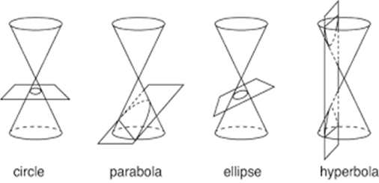

## HISTORICLA BACKGROUND

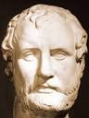The conic section seems to have been discovered by **Menaechmus** (a Greek, 360-350 B.C.), tutor to Alexander the Great. They were conceived in an attempt to solve the three famous problems of trisecting the angle, duplicating the cube, and squaring the circles. Apollonius of Perga, known as the “Great Geometer”, gave the conic sections their names and was the first to define the two branches of the hyperbola. In the years following Apollonius the Greek geometric tradition started to decline, though there were developments in astronomy, trigonometry, and algebra. Pappus, who lived about 300 A.D., furthered the study of conic sections somewhat in minor ways. After Pappus, however, conic section was nearly forgotten for 12 centuries. It was not until the sixteenth century, in part as a consequence of the invention of printing and resulting dissemination of Apollonius’s work, that any significant progress in the theory or applications of conic sections occurred; but when it did occur, in the work of Kepler, it was as part of one of the major advances in the history of science.

## OBJECTIVES

* Constructing the ellipse by arc of circle method step by step as per rule.
* Finding the facts on conic section like ellipse which is always true.
* Relation between different parameters of ellipse and hyperbola.
* Solving question related to ellipse and hyperbola.

## KEY FEATURES

* The general equation of $2^{nd}$ degree in x and y i.e. $ax^{2}+2hxy+by^{2}+2gx+2fy+c=0$ represent an ellipse if $∆=abc+2fgh-af^{2}-bg^{2}-ch^{2}≠0 and h^{2}<ab$.
* For the hyperbola $\frac{x^{2}}{a^{2}}-\frac{y^{2}}{b^{2}}=1$, the equation of asymptotes are : $x=±\left(\frac{a}{b}\right)y.$
* The general equation of $2^{nd}$ degree in x and y i.e. $ax^{2}+2hxy+by^{2}+2gx+2fy+c=0$ represent a parabola if $∆=abc+2fgh-af^{2}-bg^{2}-ch^{2}≠0 and h^{2}=ab$.
* If a line $y=mx+c$ touches the ellipse $\frac{x^{2}}{a^{2}}+\frac{y^{2}}{b^{2}}=1$ then it satisfies $c^{2}=a^{2}m^{2}+b^{2}$
* The sum of distance from a point on the ellipse and foci is always the twice of major axis. And the differences between distance from a point on hyperbola and foci is always the twice of major axis.
* The value of eccentricity for ellipse is always less than one where as its value for hyperbole is always more than one.
* The sum of distance between the locus point and two foci of ellipse is equal to length of major axis and the difference between the locus points a two foci of hyperbola is equal to length of transverse axis.
* The graph of function $f\left(x\right)=\frac{1}{x}$ is rectangular hyperbola.

## CONSTRUCTION OF ELLIPSE

The equation of ellipse is $\frac{x^{2}}{a^{2}}+\frac{y^{2}}{b^{2}}=1$. For the construction of ellipse by arc of circle method, following steps must be followed:

1. Sketch a line AA' of length 120mm and again draw a perpendicular bisector BB' on that line of length each 35mm downward and upward. Let the intersecting point be O.
2. Now measure the distance OA with the help of compass and then draw an arc on line OA and OA' taking another arm on point B. Named that two point S and S' which are the focus of the ellipse.
3. Now take any four points (I, J, K, L) between the point S and S'.
4. Take the measurement of AI and make an arc on white space spotting another arm of compass at point S. Similarly, take the measurement of A'I and intersect the arc in four different points. Then named the points I1 , I2 , I3 , I4 .
5. Following the process of step 5, make the intersection point by J, K, L respectively. Then join all the intersecting point simultaneously which will forms an ellipse.
6. Take any point Z on the ellipse and draw a line from S and S' to point Z respectively.
7. Extend the arm of compass and spot the needle point of compass at point Z then draw arc P' and P on line ZS' and ZS respectively.
8. Find the intersecting arc point Q taking the needle point on P' and P. Now draw a line joining point Z and Q. which is the normal of ellipse at Z.
9. Draw a perpendicular line with ZQ, which is the tangent of ellipse at point Z.

## GEOMETRICAL REPRESENTATION

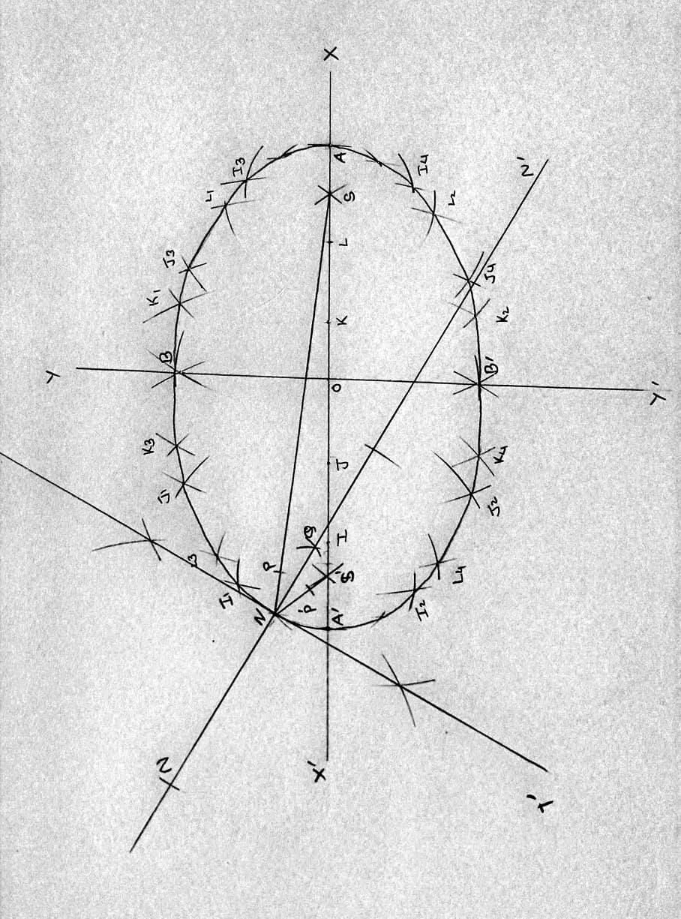

## NUMERICAL COMPUTATION

According to the given question,

Length of major axis of ellipse $\left(2a\right)=120mm⇒a=60mm$

Length of minor axis of ellipse $\left(2b\right)=70mm⇒b=35mm$

Now,

For the eccentricity of ellipse:

Eccentricity $\left(e\right)=\sqrt{1-\frac{b^{2}}{a^{2}}}$

$\sqrt{1-\frac{{35}^{2}}{{60}^{2}}}$

$\frac{\sqrt{95}}{12}$

* 0.8122

For the focus of ellipse:

Focus = $\left(±ae,0\right)$

$\left(±60×0.8122,0\right)$

$\left(±48.734,0\right)$

For the distance of directrix from the origin:

Distance of directrix from origin :

$\frac{a}{e}$

$\frac{60}{0.8122}$

* 73.87mm

## QUESTION

* In an ellipse, S and S' are the foci, A and A' are the vertices, ZM and Z'M' are the directrix, P is any point on ellipse such that PS + PS' = 12 and AZ =3. Find the vertices, center, eccentricity, foci and the equation of directrix if O is the center of ellipse as the origin and AA' as the x-axis.

Solution:

Here,

∴ $PS + PS^{'}= 12=2a$ where, $\left(±a,0\right)$ is the vertices of vertex of ellipse.

∴ $a=6$

∴ $AZ=3s⇒or,\frac{a}{e}-a=3$

Or, $a\left(\frac{1}{e}-1\right)=3$

Or, $\frac{1}{e}=\frac{3}{6}+1=\frac{3}{2}$

Or, $e=\frac{2}{3}$

For the foci of the ellipse:

The coordinate of foci is given by $\left(±ae,0\right)$

⇒ $\left(±6×\frac{2}{3},0\right)⇒\left(±4,0\right)$

The equation of directrix is given by:

∴ $x=±\frac{a}{e}$

Or, $x=±6×\frac{3}{2}$

Or, $x=±9$

## APPLICATION

* Many real- world situations can be represented by ellipses, including orbits of planets, satellites, moons and comets and shapes of boat kneels, rudders and some airplane wings.
* Hyperbola shape is extensively used in the design of bridges.
* Parabolic mirror are used to converge light beams at the focus of the parabola.
* The equation of circle can be used to make camera lens, rings, wheels etc.
* A medical device called a lithotripter uses elliptical reflectors to break up kidney stones by generating sound waves.
* Interference pattern produced by two circular waves is hyperbolic in nature.
* The path of each planet is an ellipse having the sun at one focus, according to kepler’s first law of planetary motion.
* In light housed, parabolic bulbs are provided to have a good focus of beam to be seen from distance by mariners.
* Elliptical training machines enable running or walking without straining the heart.
* Satellite systems, Radio systems use hyperbolic functions.
* Inverse relationship is related to hyperbola. Pressure and Volume of gas are in inverse relationships. This can be described by a hyperbola.
* When a tumbler of water is tilted, an elliptical surface of water is seen.

## REFERENCES

1. Nabaraj Adhikari, Amba Datt Joshi, Nabaraj Bhandari, Raghu Bir Bhatta, Hari Prapanna Kandel, *Principle of mathematics,* Kriti Publication Pvt.Ltd., Putalishadak, Kathmandu
2. N. Adhikari, H.N. Nath and et.al. *Pioneer Mathematics Grade XI and XII,* Dreamland Publication Pvt.Ltd.2014, Kathmandu, Nepal.
3. P.M. Bajracharya and G. Basnet, *Fundamental of Mathematics,*  class XI and XII, Buddha Academic, 2008, Nepal.